Curriculum Vitae
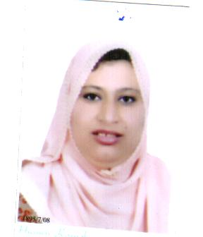

Personal Information
Saida El sayed Hassan Ibrahim El Azzab | Name
Nursing | Faculty
Lecturer of Psychiatric and Mental Health Nursing | Present Position
Female | Gender
13-2-1974 | Date of Birth
Sharkia Governorate | Place of Birth
Egyptian | Nationality
Diearb Negem Center- Sharkia Governorate | Residence Address
Married | Martial Status
Nursing | Skills
Reading, art | Hoppies
Saida_hassan@yahoo.com | E-mail
 | Web Site
0553764944 | Home Tele
01119942093 | Mobile Tele

Languages
Arabic | Language | 1
Fluent | Reading
Fluent | Writing
Fluent | Speaking
English | Language | 2
Fluent | Reading
Fluent | Writing
Good | Speaking
Education
Baccalaureate of nursing (1996) and one year internship (1997) | Name | 1
Zagazig University University | University
Nursing | Faculty
Zagazig | City
Egypt | Country
General | Specialization
Master degree (2006) | Name | 2
Zagazig University | University
Nursing | Faculty
Zagazig | City
Egypt | Country
Psychiatric and Mental Health Nursing | Specialization
2006 | Finished Date
Doctorate | Name | 3
Zagazig University | University
Nursing | Faculty
Zagazig | City
Egypt | Country
Psychiatric and Mental Health Nursing | Specialization
2012 | Finished Date
Academic Positions
Beni Suef University | University | 1
Nursing | Faculty
Beni Suef | City
Egypt | Country
Assistant Lecture of Psychiatric and Mental Health Nursing | Job
19 -5 - 2008 | Start Date
24 . 6 . 2012 | Finished Date
Beni Suef University | University | 2
Nursing | Faculty
Beni Suef | City
Egypt | Country
Lecture of Psychiatric and Mental Health Nursing | Job
25 . 6 . 2012 | Start Date
Up to now | Finished Date
Teaching Experience
Undergraduate | Level | 1
- Psychiatric and Mental Health Nursing for fourth year | Course Name
Beni Suef University | University
Nursing | Faculty
Beni suef | City
Egypt | Country
Undergraduate | Level | 2
- Communication and Human Relations . | Course Name
Beni suef University | University
Nursing | Faculty
Beni seuf | City
Egypt | Country
Training / certifications
I shared in training of " training of trainers TOT from international board of certified trainers |  | 1

