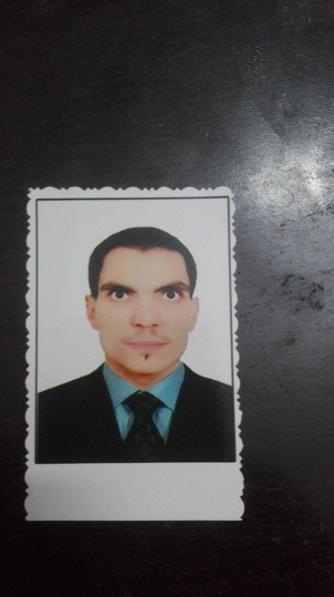

Mahmoud Alaa Elddin Fouad Abdel Razik

+201143347137

Mahmoudabdel-razik@pharm.bsu.edu.eg

25-Elmegedy Street Mallawi, Minia, Egypt

Scientific Certifications

Degree of Bachelor in Pharmaceutical Sciences (Clinical Pharmacy) with general grade Excellent (Total GPA=3.91) from the Faculty of Pharmacy, Beni-Suef University.

Current job

Demonstrator at Microbiology & Immunology Department, Faculty of Pharmacy, Beni-Suef University.

Master Student in Microbiology & Immunology Department, Faculty of Pharmacy, Beni-Suef University.

Experiences:

Two years in teaching practical microbiology and immunology courses (discussed below)

Skills

Scientific and technical skills (well organized person, good time manager, well planned person)

Computer skills (Microsoft group, Internet)

Languages skills (Arabic, English)

Other skills (Communication skills, Public and Presentation skills, Leadership skills)

* Participated in Scientific Students Conference of microbiology and immunology, Faculty of Pharmacy, BNS University.

Achievements and Activities

* Attended Plagiarism Course at BNS University.
* Attended the Training Course in the framework of the specialized research skills development programs at BNS University.
* Attended the Immunology Scientific day in Faculty of medicine, BNS University.
* Attended Clinical Pharmacy Students Training Program in University Hospital of BNS.
* TOEFL certified with 438 score.
* Teaching the following courses for undergraduate students:

-Basic Microbiology and Immunology

- Pharmaceutical Microbiology

-Pharmaceutical Biotechnology

-Medical Microbiology

-Cell Biology

-Parasitology

-Pathology